HAI-AR Outbreak and Response Tracking System

Data Dictionary (version 1)

What is this? The following materials were developed to help health departments and large healthcare systems manage information related to investigations of possible HAI-AR outbreaks involving healthcare delivery. The materials include a sample database (provided in the form of a downloadable Microsoft Access file) and data dictionary. The database is intended to be used for tracking summary data for responses activities. It is not intended to capture individual case data as would be done with a line list or a database developed for a specific epidemiologic investigation.

Why use these materials? Maintaining an electronic database of HAI-AR investigations allows a health department or healthcare system to review and summarize information to facilitate information sharing and identify strengths and gaps in reporting and investigative capacity. For health departments where HAI outbreaks are recorded in a general outbreak database including other types of outbreaks, it is important that outbreaks occurring in healthcare settings or due to healthcare exposures can be queried and extracted separately. These materials can be used to help improve current HAI-AR response activity tracking efforts or to provide a starting place for adoption of a new database dedicated to HAI-AR response activity tracking.

What types of HAI-AR Response events should be captured? Consider recording all HAI-AR response activities in your tracking system. Response refers to efforts to assist with the assessment and investigation of specific, acute HAI-AR risks, which may take the form of (1) outbreaks, (2) clusters of infections, (3) sentinel cases (e.g., HAI or emerging AR threat of public health interest), or (4) a serious breach in infection control practice.

How were these materials developed?
A workgroup was formed consisting of CORHA representatives from national, state, and local public health agencies and partner organizations. The workgroup reviewed potential data elements and used the following questions as a guide to determine which fields should be included:
- Is it critical for the data to be captured in the database? Every field in the database should ideally be reviewed for every HAI-AR response. Having a separate field for critical data elements can be helpful as a reminder to enter that information.
- Can the data be aggregated in a meaningful way? Data elements that cannot be aggregated can be stored in the ‘notes’ fields.
- Could it be useful to have the data separated out when reviewing the entry? The benefit of having a separate data field should outweigh the burden of having to review the field for every new HAI-AR response.

Field name | Field type | Dropdown list options
Response/Outbreak ID | Short Text
Status of investigation | Short Text | (Active, Monitoring, Closed)
Type of event/investigation | Short Text | (Outbreak, Cluster, Injection safety breach, reprocessing/sterilization breach, Disease/organism of public health importance)
Intake Information
Source of report | Short Text | (Healthcare Facility, Survey/Certification, Public, Public health agency, Health department surveillance)
Name – Source of report | Short Text
Phone – Source of report | Short Text
Email – Source of report | Short Text
Method of report | Short Text | (Email, Fax, Phone call)
Date public health contacted | Date & Time
Date public health investigation initiated | Date & Time
Date facility investigation initiated | Date
Description of situation when initially reported | Long Text
Healthcare Facility Information
Facility healthcare setting | Short Text | (Acute Care Hospital, Ambulatory surgical center, Dental, Dialysis inpatient, Dialysis outpatient clinic, Inpatient rehabilitation facility, Home health, LTAC, Assisted living facility, OB/GYN, Outpatient clinic, Nursing home/SNF, Urgent care)
Facility Name | Long Text
Facility Address | Short Text
Facility point(s) of contact | Long Text
County | Short Text
Region/District | Short Text
Location within facility | Short Text | (ICU, Ward, NICU, Oncology, OR, ED, Observation, Well-Baby Nursery, Labor & Delivery/Obstetrics, Radiology, Unknown)
Facility bed count (if applicable) | Number
Public Health Contact Information
Lead investigator | Short Text
Other health dept. staff involved and contact information | Long Text
Other agencies/departments involved | Short Text | (FDA, CDC, CMS, DEA, Medical board, Nursing board, Other licensing board, Outside consultant, Survey and certification, State health department, Local health department)
Name of contact for agencies/departments | Short Text
Phone number for agencies/departments | Short Text
Email for agencies/departments | Short Text
Notes for agencies/departments | Long Text
Epidemiological Investigation
Epidemiological investigation notes | Long Text
Number of cases - confirmed | Number
Number of cases - probable | Number
Number of cases - suspected | Number
Date case count last updated | Date
Case definition(s) | Long Text
Date of potential exposure – start | Date
Date of potential exposure – end | Date
Date of illness onset - first case | Date
Date of illness onset - last case | Date
Date of specimen collection - first case | Date
Date of specimen collection - last case | Date
Type of infection | Short Text | (Bloodstream infection (BSI), Respiratory tract infection (RTI), Urinary tract infection (UTI), Eye infection, Skin/Soft tissue infection (SST), Surgical site infection (SSI), Gastrointestional infection (GI), Neurological infection)
Number reported exposed | Number
Number with symptomatic infection | Number
Number with asymptomatic colonization | Number
Number of hospitalizations | Number
Number of deaths | Number
Was there illness among healthcare workers? | Yes/No
If yes, describe illness among healthcare workers | Long Text
Investigation method(s) | Short Text | (Additional case finding, Interviews, Chart reviews, Environmental inspection)
Investigation resource(s) used | Short Text | (Dropdown to be populated by end user with Infection Control tools and other helpful investigation resources, some of which may be publically available)
Investigation resource(s) used – Website Link | Short Text (Hyperlink)
Suspected source(s) of transmission | Short Text | (Patient to Patient, Cleaning and disinfection, Other environmental pathway, Food, Facility Water System, Medication, Colonized or Infected Healthcare Worker, Injection Safety Breach, Reprocessing Breach)
Health dept. on-site visits
On-site visit - date | Date
On-site visit - primary reason for visit | Short Text | (Deaths, Unknown Source, Unknown Agent, High Profile, Observation of Practices, Environmental Assessment, Collect Samples/Specimens, Requested by facility, Other)
On-site visit - notes | Long Text
On-site visit - participant name | Short Text
On-site visit - participant affiliation | Short Text
Notifications
Notification - type | Short Text | (Patient notification, Provider notification, Public notification)
Notification - date | Date
Notification - number notified | Number
Notification - testing performed | Yes/No
Notification - number tested | Number
Notification - notes | Long Text
Notification – number additional cases identified | Number
Laboratory Testing
Pathogen(s) identified | Short Text | (Pathogen list)
Pathogen - Resistance mechanism(s)/profile | Short Text | (IMI-carbapenamase gene, IMP-carbapenamase gene, KPC-carbapenamase gene, NDM-carbapenamase gene, OXA-carbapenamase gene, VIM-carbapenamase gene, mcr gene, ESBL, pan-resistant)
Laboratory notes | Long Text
Laboratory - sample type | Short Text | (Clinical, Environmental)
Laboratory - testing lab | Short Text | (ARLN, CDC, Clinical/Facility, Commercial, State)
Laboratory - number tested | Number
Laboratory - number positive | Number
Laboratory - surveillance? | Yes/No
Laboratory - molecular testing? | Yes/No
Laboratory - number molecular testing | Number
Control Measures
Control measure(s) implemented | Short Text | (Isolated patients/residents, Cohorted patients/residents, Cohorted Staff, Restricted Visitation, Closed to new admissions, Environmental Cleaning, Education/Training, Auditing, Discontinue group activities, Facility closure, Water disinfection, Changes in disinfection/sterilization)
Number vaccinated | Number
Number receiving prophylaxis | Number
Control measure(s) notes | Long Text
Summary and Conclusions
Date closed | Date
Final summary and resolution | Long Text
Shaded fields indicate repeating sections that allows multiple entries per response

Screenshots from Microsoft Access database
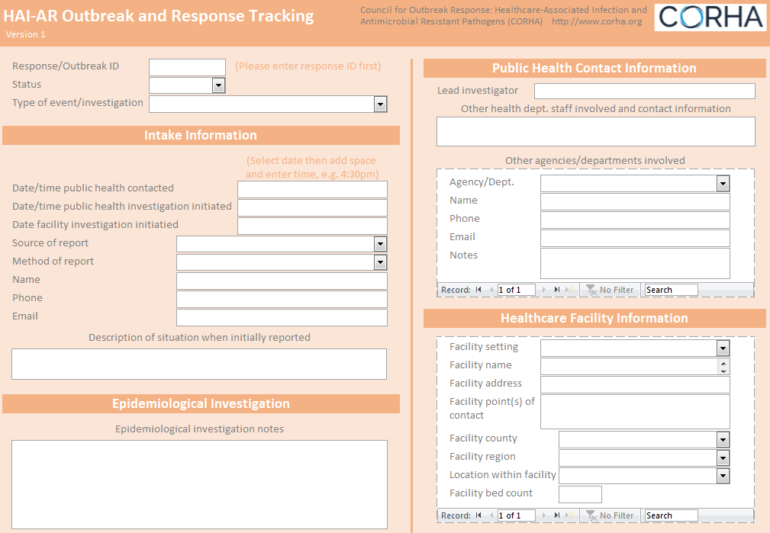
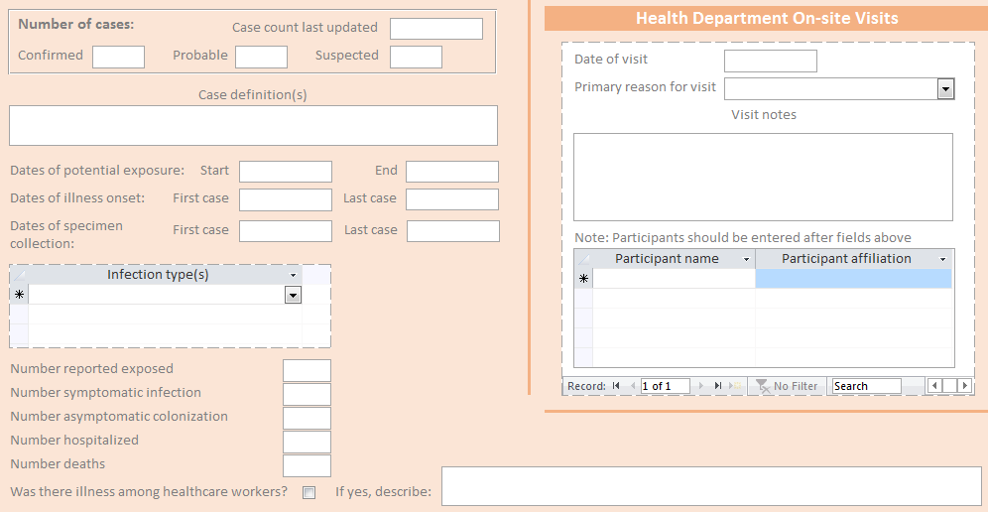

Screenshots from Microsoft Access database (cont.)
